Exercise 2
- Write the SELECT statement to extract the ids of employees who are 30 years of age.
select emp_id from employee_data where age > 30;
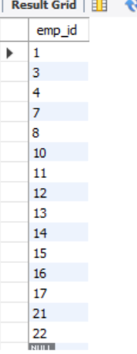
- Write the SELECT statement to extract the first and last names of all web designers.
select f_name, l_name from employee_data where title = 'Web Designer';
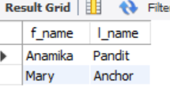
- What will the following SELECT statement display:
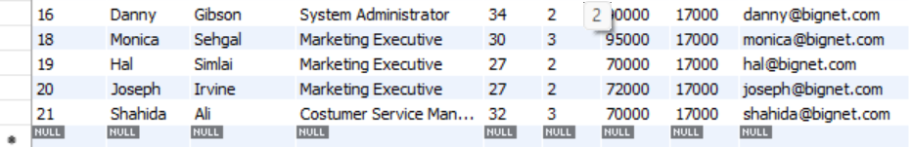
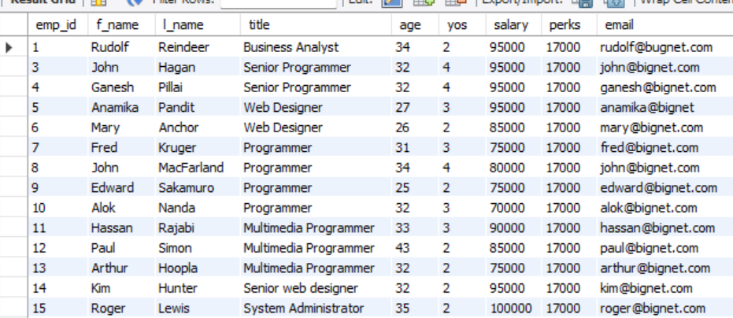
Select*from employee_data where salary <=100000;

- How will you display the salaries and perks for employees who have more than $16000 as perks?
select salary, perks from employee_data where perks > 16000;

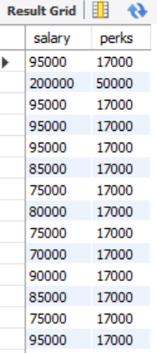

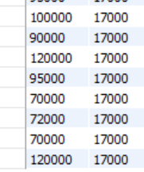

5.List all employee names (last name followed by first name) who hold the title of Marketing Executive.
select CONCAT(l_name, f_name) AS employee_name from employee_data where title = 'Marketing Executive';
